**PRACTICAL-7**

**AIM:**

**a.** Write a program to demonstrate recursion in Python.

**Source Code:**

def factorial(n):

if n == 0:

return 1

else:

return n * factorial(n - 1)

# Example usage:

result = factorial(5)

print("Factorial of 5 is:", result)

**Output:**

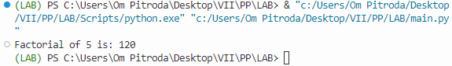

**b.** Create a function for Stack data structure in Python and implement necessary operations.

**Source Code:**

class Stack:

def __init__(self):

self.items = []

def push(self, item):

self.items.append(item)

def pop(self):

if not self.is_empty():

return self.items.pop()

def is_empty(self):

return len(self.items) == 0

def peek(self):

if not self.is_empty():

return self.items[-1]

def size(self):

return len(self.items)

my_stack = Stack()

my_stack.push(1)

my_stack.push(2)

my_stack.push(3)

print("Stack size:", my_stack.size())

print("Top element:", my_stack.peek())

print("Popped element:", my_stack.pop())

print("Is the stack empty?", my_stack.is_empty())

**Output:**

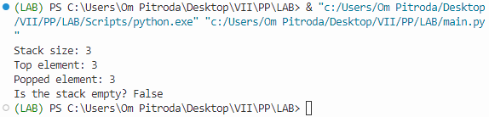

**c.** Create a function for Queue data structure in Python and implement necessary operations

**Source Code:**

from collections import deque

class Queue:

def __init__(self):

self.items = deque()

def enqueue(self, item):

self.items.append(item)

def dequeue(self):

if not self.is_empty():

return self.items.popleft()

def is_empty(self):

return len(self.items) == 0

def size(self):

return len(self.items)

# Example usage:

my_queue = Queue()

my_queue.enqueue(1)

my_queue.enqueue(2)

my_queue.enqueue(3)

print("Queue size:", my_queue.size())

print("Dequeued element:", my_queue.dequeue())

print("Is the queue empty?", my_queue.is_empty())

**Output:**

